POS SYSTEM – ARCHITECTURE DRIVERS

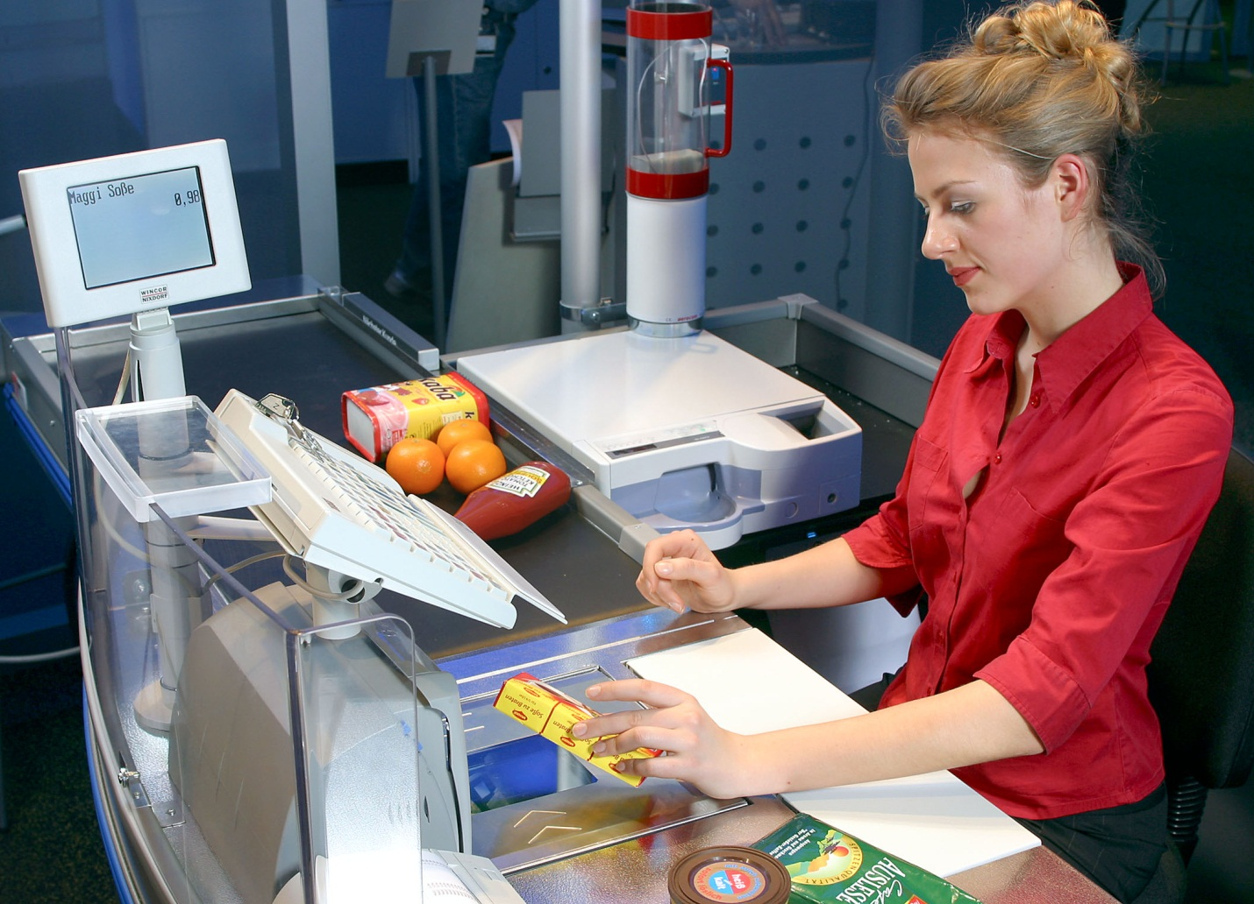

HIT Team

Consulting

Sales

Staffing

Support

# Information of document

|  |  |
| --- | --- |
| Title | **Architecture Driver Document** |
| Author(s) | All team |
| Reviewer(s) | All team |
| Team name | HIT Team |
| Team members | Thanh Giang, Hiep Ta, Phuc Nguyen, Giang Nguyen, Dat Tran, Huy Huynh |
| Project mentors | Ms. Huong Nguyen, Mr. Huyen Pham |
| Editor |  |
| Type of report | Architecture Driver Document |
| Software used | MS Word |

# Document Reviewer Information

|  |  |  |
| --- | --- | --- |
| **Reviewer Name** | **Review Attendance (R/S)** | **Comments** |
|  |  |  |
|  |  |  |
|  |  |  |

# Document Approver Information

|  |  |  |
| --- | --- | --- |
| **Approver Name** | **Approver Function** | **Comments** |
|  |  |  |
|  |  |  |
|  |  |  |

# Document Revision History

|  |  |  |  |  |
| --- | --- | --- | --- | --- |
| **Date** | **Revision** | **Status** | **Change Summary** | **Revised by** |
| 6/3/2012 | 1.0 |  | Consume Team member’s tasks | Thanh Giang |
| 15/4/202 | 1.1 |  | Update Quality Attributes | Giang Nguyen |
| 18/4/2012 | 1.2 |  | Usecase | Thanh Giang |
| 24/05/2012 | 1.3 |  | Use case Description | Hiep Ta |

1. **INTRODUCTION** 
   1. **Purpose of this document**

This section of the Architectural Driver gives an overview of the business context and the architectural drivers with their impact on the project. It also contains the project deliverables, the summary of the schedule the SPMP. We also show the development strategy that we choose to show how this may affect the design of a system.

* 1. **Project Summary**

The project will aim to develop a sale system for Company A, a retail chain (hereinafter, the system) in conjunction with its launch of a point service.

The system consists of a main server, located at the head office. The head office server and the POS terminals are connected to each other via a network. Products sold at stores have bar codes attached which indicate the product codes. These bar codes can be read with bar code readers of POS terminals. Customer who have become point service members are issued point cards, which bear bar codes indicating their member numbers, and when they purchase products with cash, they are awarded points based on the amount of their purchase.

For each product, its standard price, common to all stores, is set as a part of the product data. Each store, however, can set and use its own actual retail price instead of the standard price during the limited period specified is each store. The actual retail price must be set in advance, and it cannot be charged in the middle of the specified period.

Products are classified into product types such as food, general merchandise, etc. Not all stores carry every product type, and the range of product types carried is designated for each store.

Customer also use online website at everywhere to check their information such as personal information, loyal point.

* 1. **Document's intended audience**

|  |  |
| --- | --- |
| Intended Audience | Reading Suggestions |
| Project Manager | Section 2 – The architectural Drivers: List functions showed by use-case diagrams and constrains to make the Project Manager has an overview. So he can have the estimates for the project.  Section 3 – The development Strategy |
| Software Architecture and Designer | Section 2 – The architectural Drivers: This section describes Use-case diagram and Use-case descriptions. It makes easily to design and develop the proposed system. |
| Tester | The Overview section and Use-case: they will help to make the test plan and write the acceptance test |

1. **The architectural drivers**
   1. **High-level Functional Requirements**

|  |  |  |  |
| --- | --- | --- | --- |
| Use Case ID | Use Case Name | Important Level | Difficulty Level |
| User Management | | | |
| UC_SM01 | Add New User | High | High |
| UC_SM02 | Search/ View User List | Medium | Low |
| UC_SM03 | View User Detail Information | Normal | Low |
| UC_SM04 | Update User Information, Assign Authorize | High | High |
| Product Management | | | |
| UC_PM01 | Add New Product | High | Medium |
| UC_PM02 | Search/ View Product List | Medium | Low |
| UC_PM03 | View Product Detail Information | Medium | Low |
| UC_PM05 | Update Product Information | Medium | Medium |
| Bill Management | | | |
| UC_RM01 | Add New Bill | High | High |
| UC_RM02 | Search/ View Bill List | Medium | Low |
| UC_RM03 | View Bill Detail Information | Medium | Low |
| UC_RM04 | Print Bill | Medium | Medium |
| Retail Stores Management | | | |
| UC_RSM01 | Add New Store | High | Medium |
| UC_RSM02 | Search/ View Store List | Medium | Low |
| UC_RSM03 | View Store Detail Information | Medium | Low |
| UC_RSM04 | Update Store Information | Medium | Medium |
| Category Management | | | |
| UC_CM01 | Add New Category | High | Medium |
| UC_CM02 | Search/ View Category List | Medium | Low |
| UC_CM03 | View Category Detail Information | Medium | Low |
| UC_CM04 | Update Category Information | Medium | Medium |
| Member Management | | | |
| UC_C01 | Add New Member | High | Medium |
| UC_C02 | Search/ View Member List | Medium | Low |
| UC_C03 | View Member Detail Information | Medium | Low |
| UC_C04 | Update Member Information | Medium | Medium |
| UC_C05 | View Member Point Log | High | Medium |
| Statistic | | | |
| UC_S01 | Analysis Statistic | Low | High |
| User Computer Management | | | |
| UC_P01 | Add New User Computer | High | Medium |
| UC_P02 | Search/ View User Computer List | Medium | Low |
| UC_P03 | View User Computer Detail Information | Medium | Low |
| UC_P04 | Update User Computer Information | Medium | Medium |
| View Point | | | |
| UC_VP | View Point | High | High |

* + 1. **Entity table**

|  |  |
| --- | --- |
| Entity | Description |
| Administrator | Responsible for manage user of the system such as: Create new, assign authorize. Manage User Computer by setting static IP; avoid unauthorized users logging in from elsewhere. |
| Manager | Responsible for manage information of retail stores, and they can statistic sales by many criterion |
| Staff | Responsible for manage information of products, categories, Member |
| Cashier | Responsible for check bills (bills) |
| User | Includes Manager, cashier and admin: they can use basic function like: log in, logout, change password |

* + 1. **Use-case Diagrams and Use-case Descriptions**

***Please Reference “POSSystem_Usecase”***

* 1. **Constrains:**
     1. **Business Constrains:**

|  |  |  |
| --- | --- | --- |
| Consideration | ID | Business Constraints. |
| Schedule limitations. | **BC01** | 1 Project Management – 120h (4h/day) |
| 2 Programmer – 120h (4h/day) |
| 1 Architect – 90h (3h/day) |
| 2 Tester – 90h (3h/day) |
| 1 Requirement -180h (6h/day) |
| Organizational restrictions and demands. | **BC02** | One team with 6 members |
| Market restrictions and demands | **BC03** | Produced only for ABC Company |

* + 1. **Technical Constrains:**

|  |  |  |
| --- | --- | --- |
| Consideration. | ID | Technical Constraints |
| Peripheral or network hardware. | TC01 | Database server, Web server, Router |
| Commercial hardware or software products. | TC02 | Bar code readers  Keyboard  Computer |
| Tools and methods. | TC03 | Visual Studio 2010, SQL Server Management Studio 2008.  .Net Framework |
| Protocols, interfaces, standards. | TC04 | TCP/IP protocol |
| Computer operating system(s) | TC05 | Window 7 |
| Computer languages(s) |  | C# ASP.Net, MVC 3.0, Entity Framework |

* 1. **Quality Attributes**

|  |  |  |
| --- | --- | --- |
| Quality | Concern | Description |
| Performance | Response time | Indication of responsiveness of a system to execute any action within a given time interval. It can be measured in terms of latency or throughput. Latency is the time taken to respond to any event. Throughput is the number of events that take place within a given amount of time |
| Delay time | For interactive into systems requires more time to handling, these transactions are processed and with an average latency of two seconds. |
| Availability | Easy to configure | Concerned with system failure and its associated consequences. A system failure occurs when the system no longer delivers a service consistent with its specification |
| Security | Security Member’s information | The capability of a system to prevent malicious or accidental actions outside of the designed usage, and to prevent disclosure or loss of information. A secure system aims to protect assets and prevent unauthorized modification of information |

The Quality Attributes ranking must base on both priority of stakeholder (Important) and project team. The following ranking table has 5 point scale increase from 1 to 5.

QA will be calculate in Priority column with formula Priority = (SP*2 + TP)/3

* The priority is high if point >= 4.0
* The priority is medium if point 3.5<= Final <4.0
* The priority is medium if point Final <3.5

**Quality Attribute Ranking Table**

|  |  |  |  |  |  |
| --- | --- | --- | --- | --- | --- |
| Quality Attributes | QA_ID | Short Description | Stakeholder Point | Team Point | Priority |
| Performance | QA_P01 | Sales staff scanning products code while the system is operating normally, |  | 5 |  |
| QA_P02 | The manager performs the statistical reports while the system is operating normally |  | 5 |  |
| QA_P03 | The staff scans the Member's card while the system is operating normally |  | 5 |  |
| QA_P04 | Sales staff sends confirmation of payment request while the system is operating normally |  | 5 |  |
| Availability | QA_A01 | Computer in retail store send a request for bill payment to server in head office while the system is operating normally. |  | 3 |  |
| Security | QA_S01 | Sales staff login into the system from an external computer while the system is operating normally |  | 4 |  |
| QA_S02 | The manager request to view a statistical report from any computer with an internet connection while the system is operating normally. |  | 4 |  |

* + 1. **Performance:**

Sales staff scanning products code while the system is operating normally, the system will display product’s information within 1 second

|  |  |
| --- | --- |
| Portion of scenario | Possible values |
| Scenario ID | QA_P01 |
| Source | Sales staff |
| Stimulate | Scanning products code |
| Artifact | System, information in the system |
| Evironment | System is operating normally |
| Respone | Display product’s information |
| Respone measure | within 1 second |

The manager performs the statistical reports while the system is operating normally, the system displays information reported within 5 seconds

|  |  |
| --- | --- |
| Portion of scenario | Possible values |
| Scenario ID | QA_P02 |
| Source | The manager |
| Stimulate | Performs the statistical reports |
| Artifact | System, information in the system |
| Evironment | System is operating normally |
| Respone | System displays information reported |
| Respone measure | Within 5 seconds |

The staff scans the Member's card while the system is operating normally; the system displays the Member information within 2 s

|  |  |
| --- | --- |
| Portion of scenario | Possible values |
| Scenario ID | QA_P03 |
| Source | The staff |
| Stimulate | Scans the Member's card |
| Artifact | System, information in the system |
| Evironment | System is operating normally |
| Respone | System displays the Member information |
| Respone measure | Within 2 s |

Sales staff sends confirmation of payment request while the system is operating normally, system confirm request, save billing information in the database and notify successful payment within 2 s

|  |  |
| --- | --- |
| Portion of scenario | Possible values |
| Scenario ID | QA_P04 |
| Source | Sales staff |
| Stimulate | Sends confirmation of payment request |
| Artifact | System, information in the system |
| Evironment | System is operating normally |
| Respone | System confirm request, save billing information in the database and notify successful payment |
| Respone measure | Within 2 s |

* + 1. **Availability:**

Computer in retail store send a request for bill payment to server in head office while the database has been crash. The system will accept payment requests, stores the information in the database backup and respond to machines in retail store with no downtime

|  |  |
| --- | --- |
| Portion of scenario | Possible values |
| Scenario ID | QA_A01 |
| Source | Computer in retail store |
| Stimulate | request for bill payment |
| Artifact | System, information in the system |
| Evironment | The database has been crash |
| Respone | The system will accept payment requests, stores the information in the database backup and respond to machines in retail store |
| Respone measure | No downtime |

* + 1. **Security**

Cashiers login into the system from a computer outside of the retail store while the system is operating normally. The system will not allow logins and sends out a message to the user that they can’t log in from external computer systems

|  |  |
| --- | --- |
| Portion of scenario | Possible values |
| Scenario ID | QA_S01 |
| Source | Cashiers |
| Stimulate | Login into the system from a computer outside of the retail store |
| Artifact | System, information in the system |
| Evironment | System is operating normally |
| Respone | The system will not allow logins and sends out a message to the user that they can’t log in from external computer systems |
| Respone measure | Within 2 s show “Login failed” message |

The manager request to view a statistical report from any computer with an internet connection while the system is operating normally. The system displays the information reported within 5 seconds

|  |  |
| --- | --- |
| Portion of scenario | Possible values |
| Scenario ID | QA_S02 |
| Source | The manager |
| Stimulate | Request to view a statistical report from any computer with an internet connection |
| Artifact | System, information in the system |
| Evironment | System is operating normally |
| Respone | The system displays the information reported |
| Respone measure | Within 5 seconds |

## -- The End --